SOFTWARE TESTING & BUG FIXING — COMPLETE DOCUMENTATION

1. Introduction to Software Testing
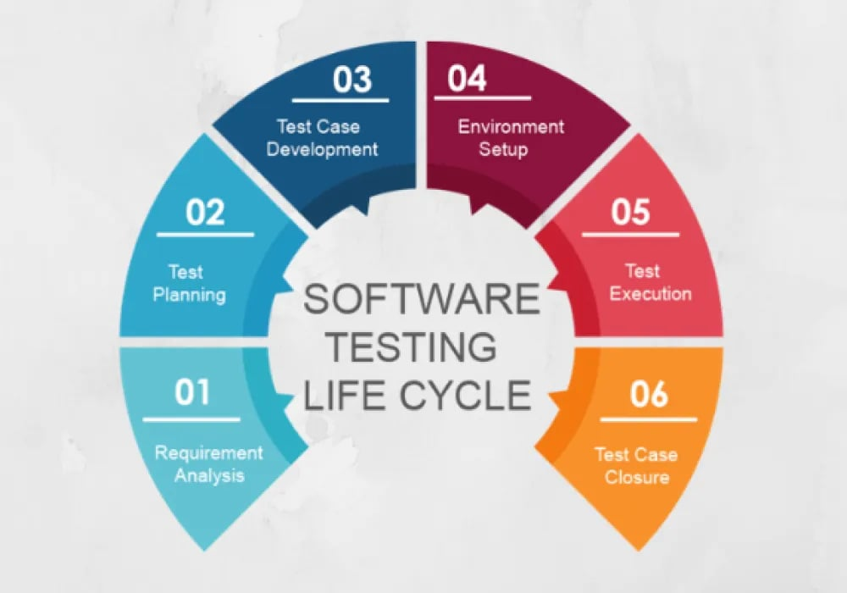
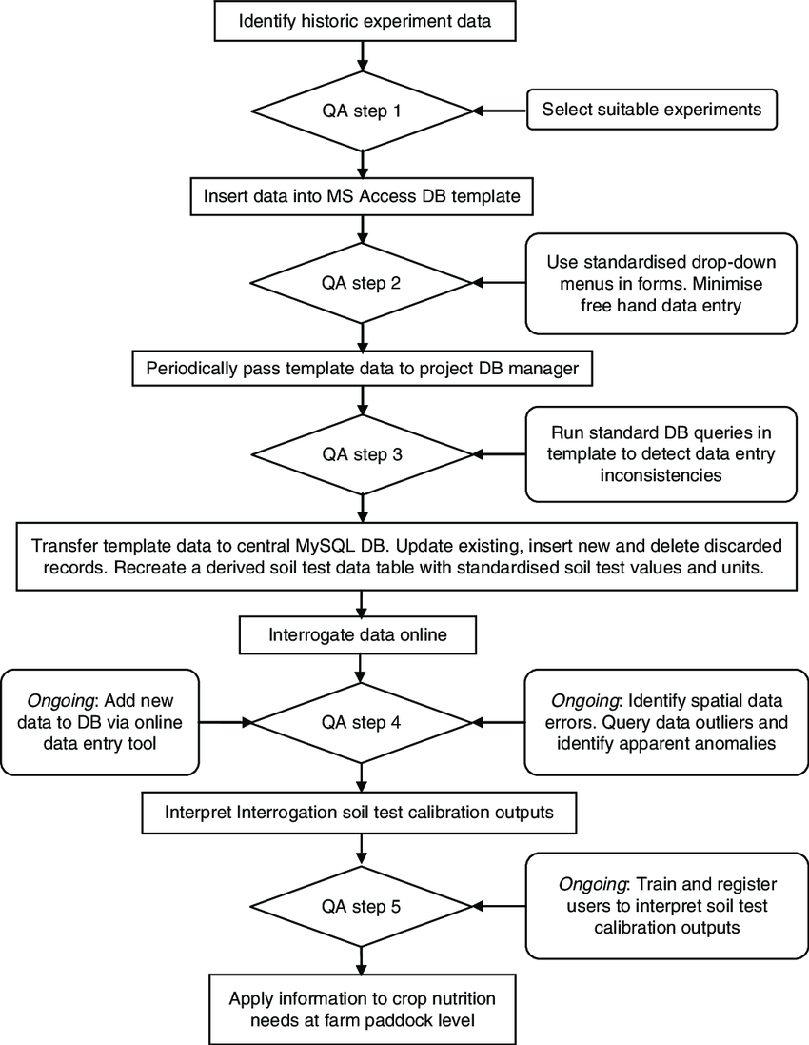
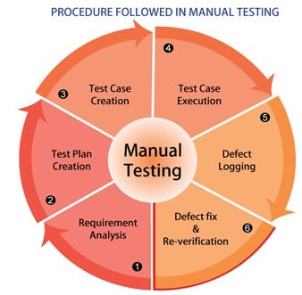

Software Testing is a structured process used to verify and validate whether a software application works according to business requirements and user expectations.

🎯 Main Objectives
- Ensure application quality
- Detect defects early
- Improve performance & reliability
- Reduce production failures
- Deliver customer satisfaction
In real companies, testing is performed before releasing software to production to avoid business loss.

📌 2. Software Testing Life Cycle (STLC)
The STLC (Software Testing Life Cycle) defines systematic testing stages followed by QA teams.

STLC Phases
1️⃣ Requirement Analysis
2️⃣ Test Planning
3️⃣ Test Case Design
4️⃣ Test Environment Setup
5️⃣ Test Execution
6️⃣ Test Closure

Detailed Explanation
Requirement Analysis
- Understand Business Requirement Document (BRD)
- Identify testable features
- Clarify doubts with developers/business team
Test Planning
- Define testing strategy
- Resource allocation
- Timeline estimation
- Risk identification
Test Case Design
- Create detailed test scenarios
- Prepare positive & negative cases
Environment Setup
- Configure server, database, browser, tools
Test Execution
- Execute test cases
- Capture results
- Report defects
Test Closure
- Prepare final testing report
- Lessons learned documentation

3. Test Case Documentation (Core Part)
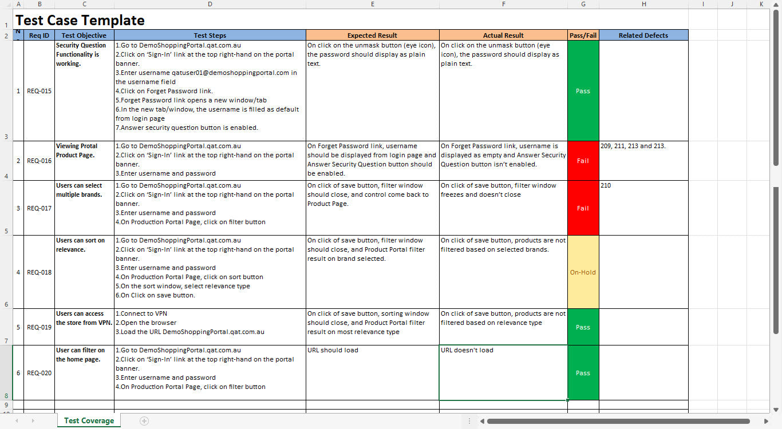
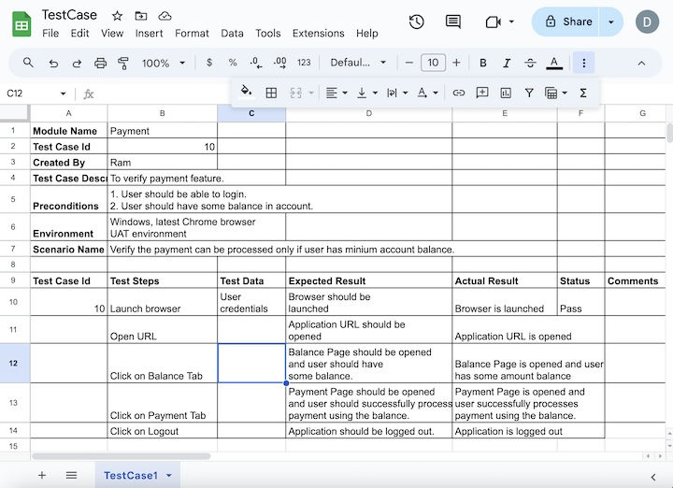
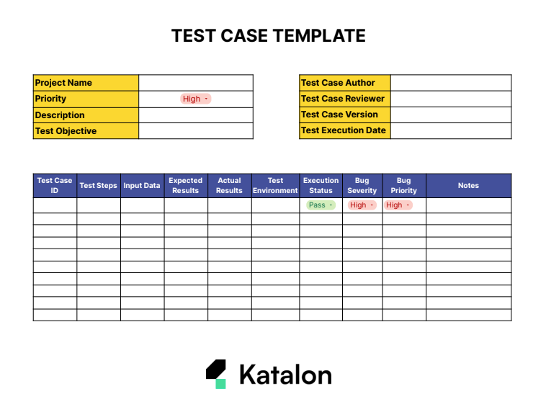
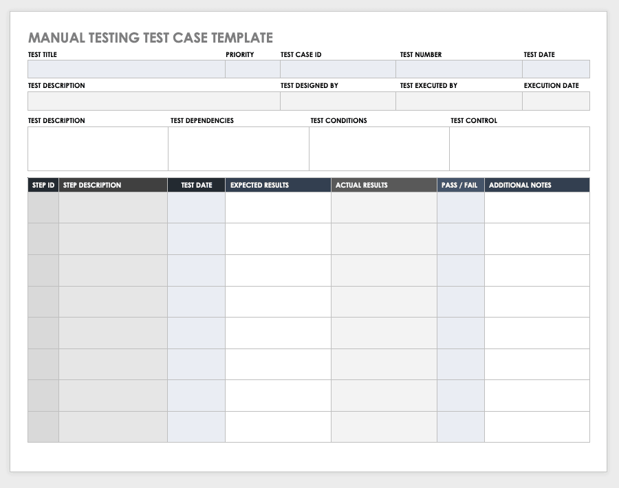
A Test Case is a detailed instruction set used to verify application functionality.

✅ Standard Test Case Format (Company Level)
Field | Description
Test Case ID | Unique identification
Module Name | Feature being tested
Test Scenario | What we are testing
Preconditions | Required setup
Test Steps | Actions performed
Expected Result | Correct behavior
Actual Result | Real output
Status | Pass / Fail
Tested By | QA Engineer
Date | Execution date

Example — Login Module
Test Case ID: TC_LOGIN_001
Scenario: Login with valid credentials
Steps
- Open login page
- Enter username
- Enter password
- Click Login
Expected Result
→ User should navigate to dashboard.

Types of Test Cases
✅ Functional Testing
✅ UI Testing
✅ Validation Testing
✅ Boundary Testing
✅ Negative Testing
✅ Regression Testing

4. Bug / Defect Explanation
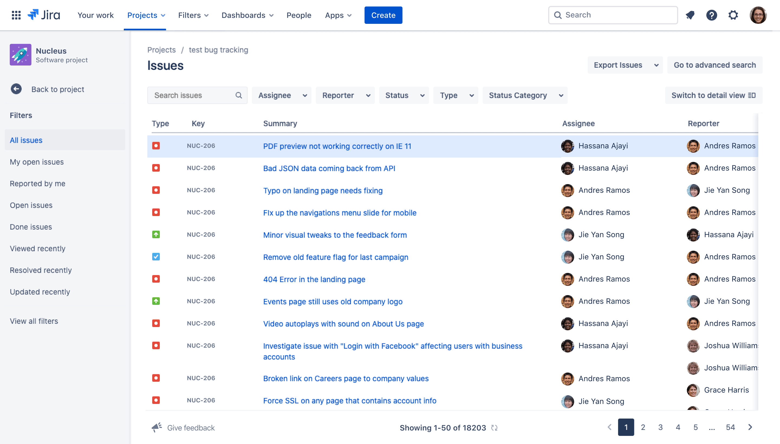
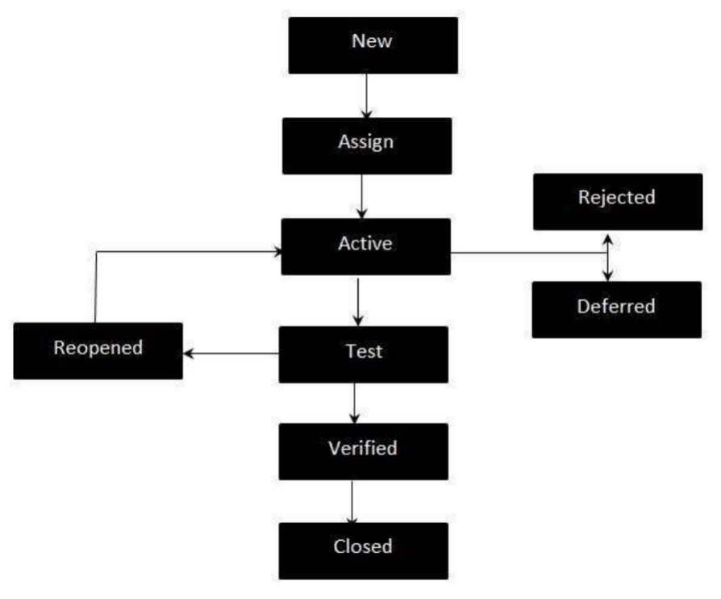
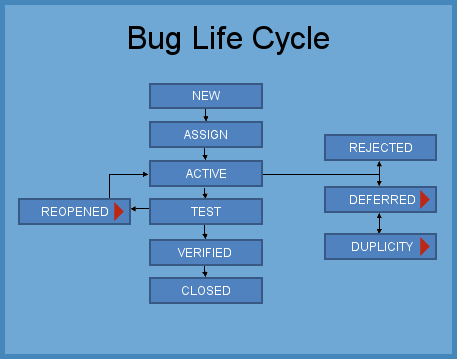
A Bug (Defect) is a mismatch between expected and actual software behavior.

Example Bugs
- Button not clickable
- Wrong calculation
- Page crash
- Login failure
- Slow performance

5. Bug Reporting Process (Professional Flow)

Step 1 — Detect Bug
Tester finds failure during execution.

Step 2 — Reproduce Issue
Confirm bug occurs consistently.

Step 3 — Capture Evidence
- Screenshots
- Logs
- Error messages

Step 4 — Create Bug Ticket

🐞 Bug Report Template
Field | Example
Bug ID | BUG_101
Title | Login Button Not Working
Module | Authentication
Severity | High
Priority | Urgent
Steps | Enter credentials → Click login
Expected | Login success
Actual | Nothing happens
Environment | Chrome / Windows

6. Bug Life Cycle (Very Important for Interviews)

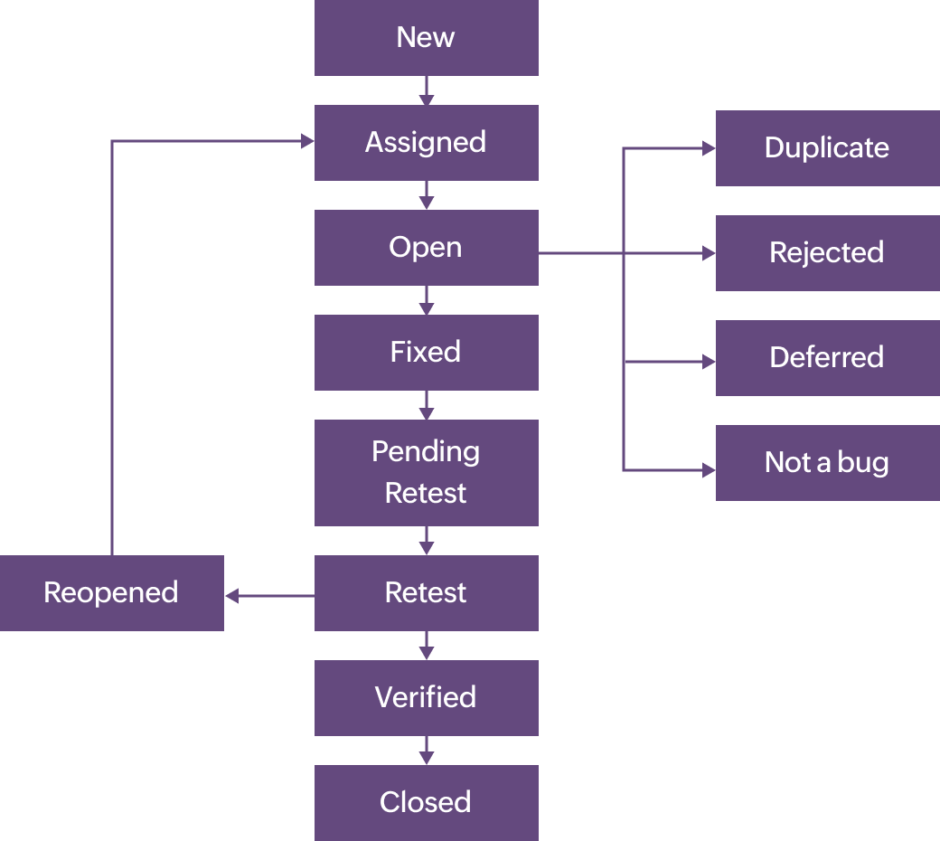
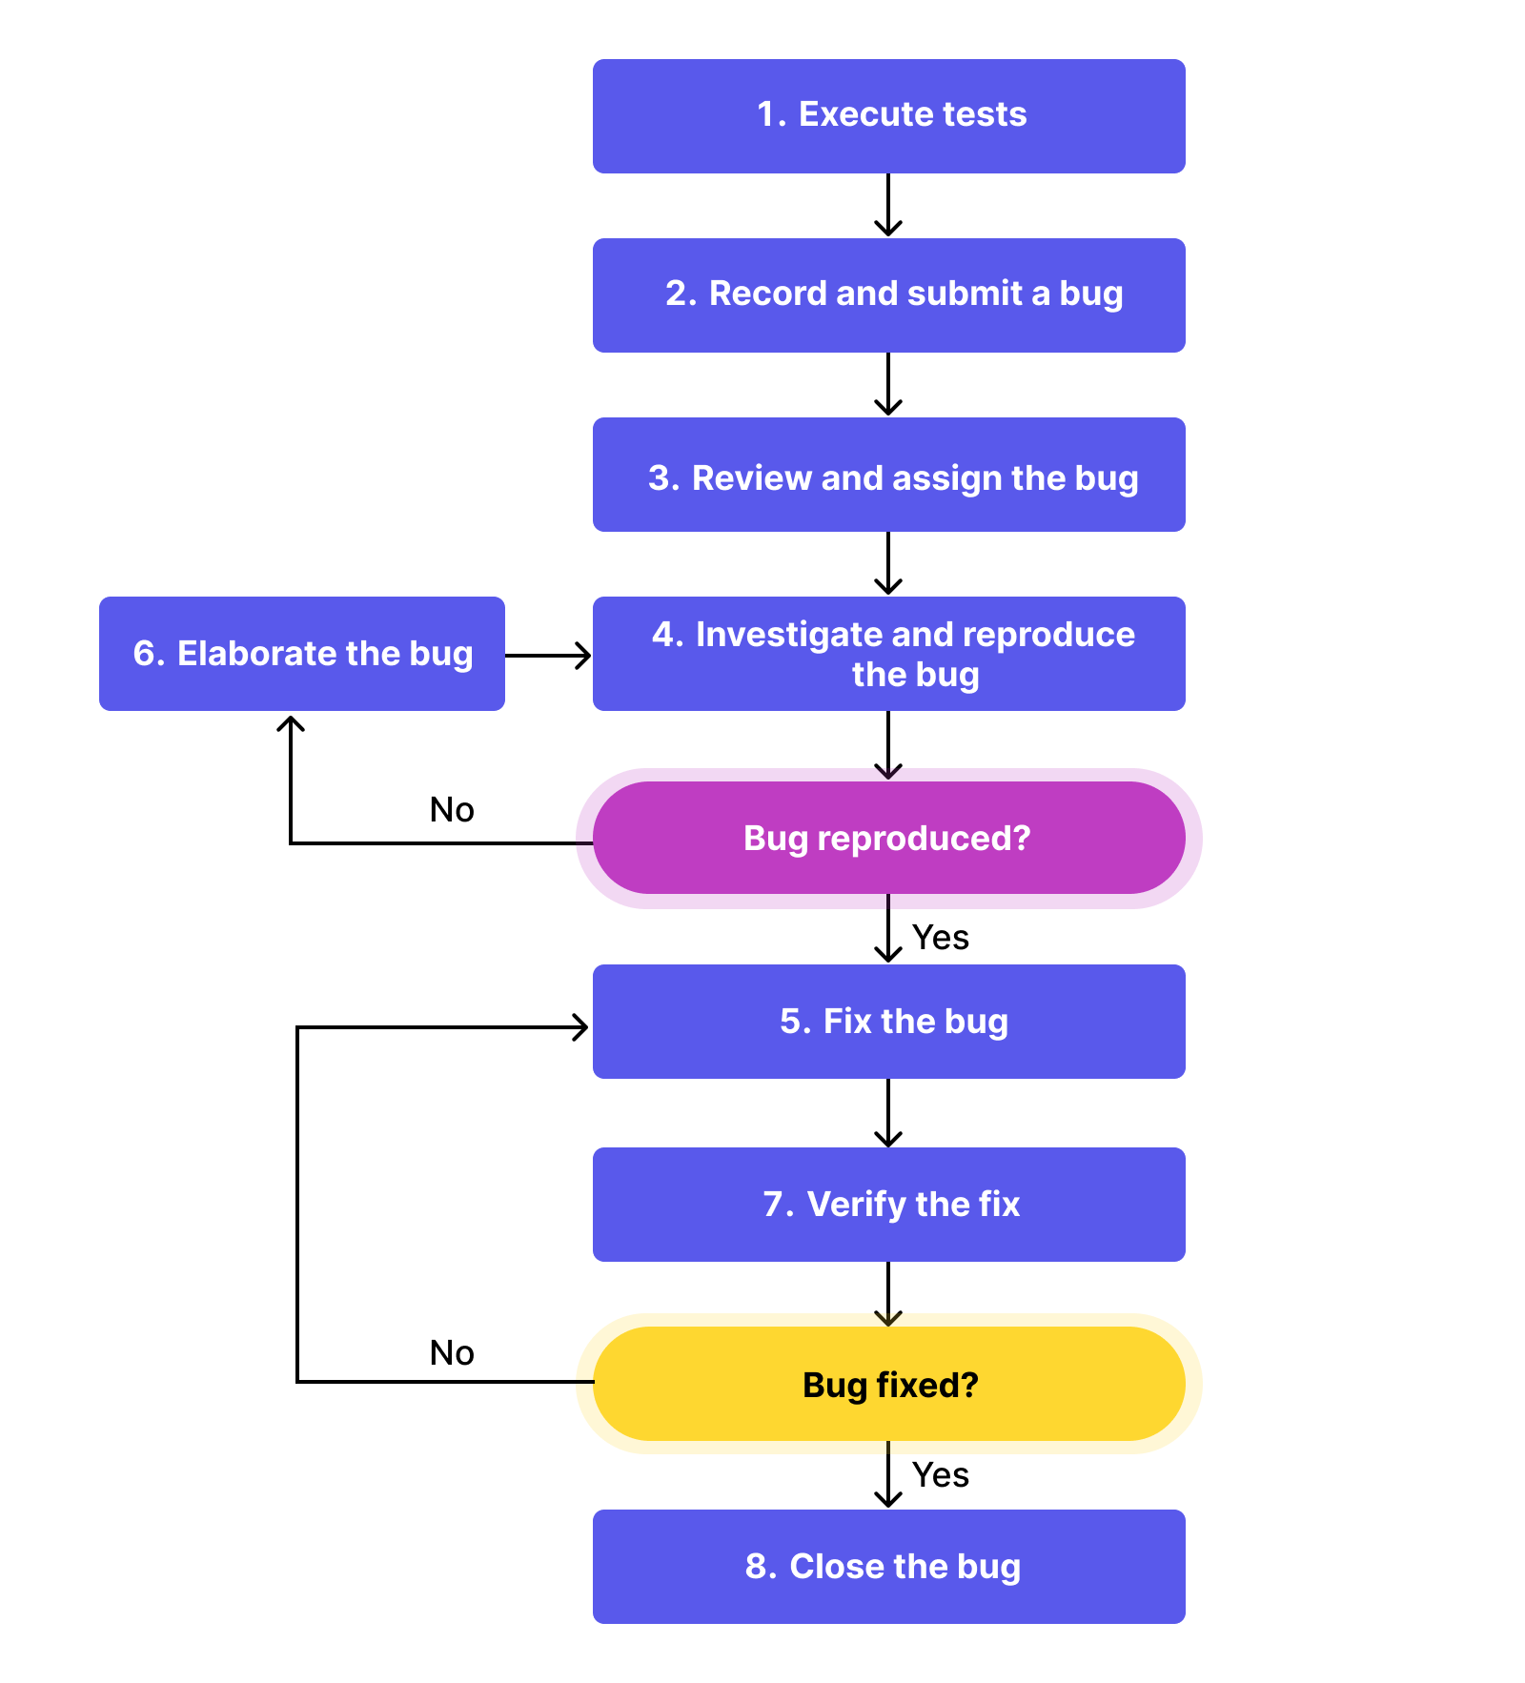
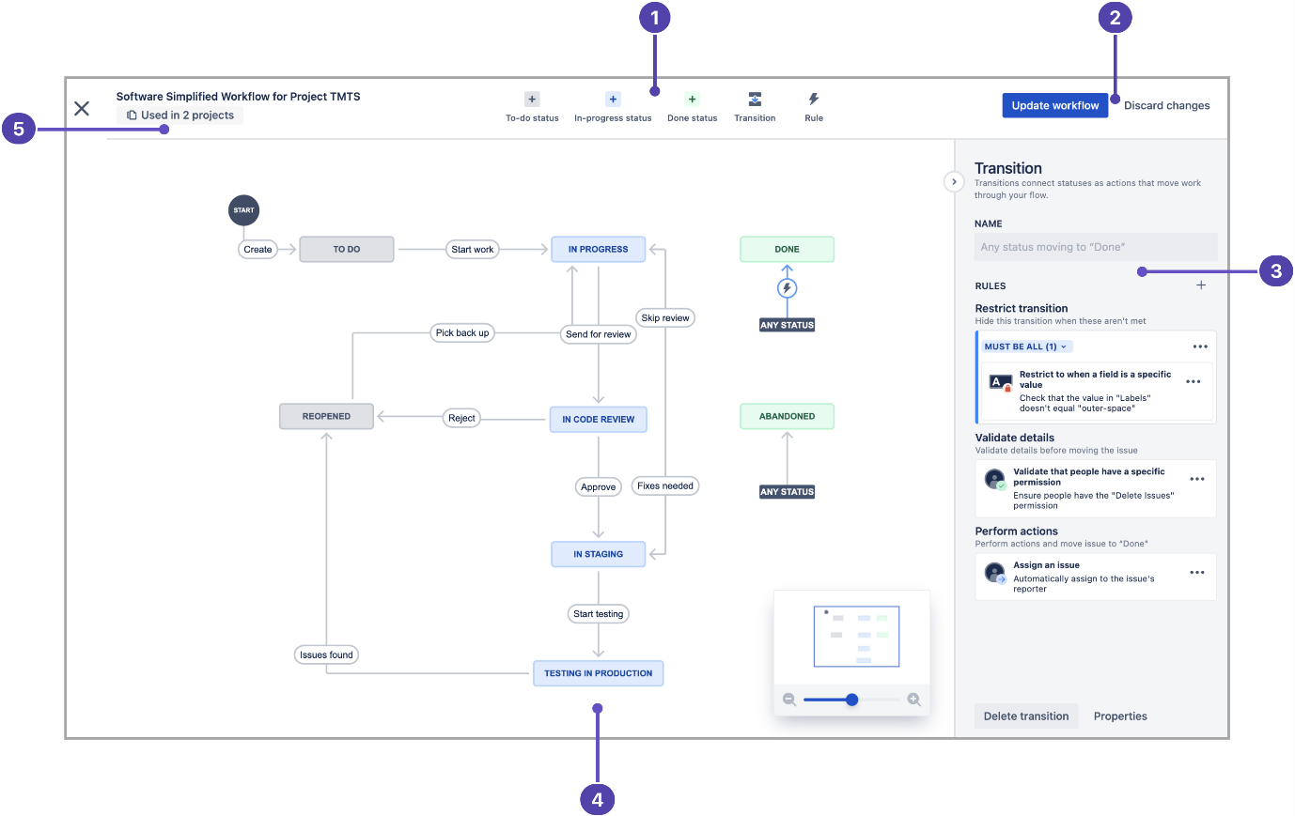
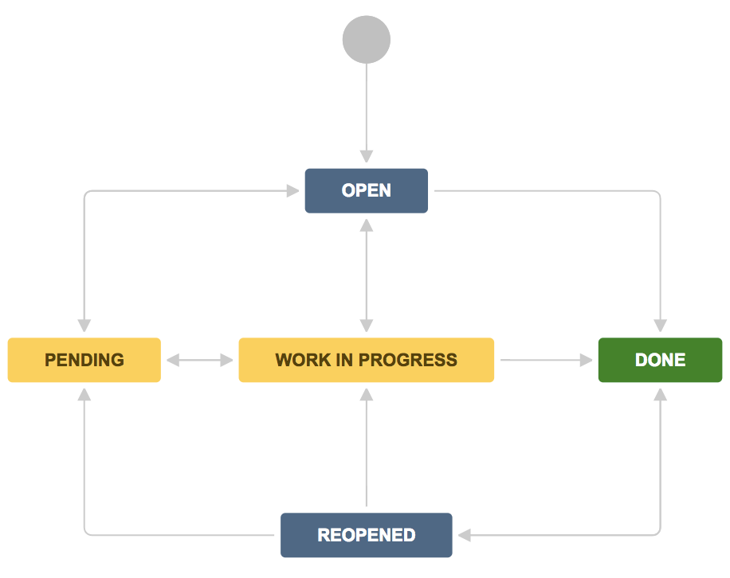

Bug Status Flow
1️⃣ New
2️⃣ Assigned
3️⃣ Open
4️⃣ In Progress
5️⃣ Fixed
6️⃣ Retest
7️⃣ Closed
8️⃣ Reopened (if still exists)

7. Bug Fixing Process (Developer + Tester Collaboration)

Developer Activities
- Analyze root cause
- Debug source code
- Fix logic or API
- Update database query
- Commit changes

Tester Activities
- Retest functionality
- Perform regression testing
- Verify no new issues introduced

8. Severity vs Priority (Interview Favorite Question)
Severity |  | Meaning
Critical |  | System crash
High |  | Major feature failure
Medium |  | Partial issue
Low |  | UI alignment
Priority | Meaning
High | Fix immediately
Medium | Next release
Low | Later improvement

9. Testing Tools Used in Companies
- Jira (Bug Tracking)
- TestRail
- Selenium
- Postman
- GitHub
- Jenkins

10. Best Practices (Real Company Standards)
✅ Write clear test steps
✅ Use reusable test cases
✅ Always attach screenshots
✅ Verify environment details
✅ Communicate with developers
✅ Maintain documentation history

PROFESSIONAL SUMMARY (You can say in Interview)
“I prepare detailed test cases based on requirements, execute testing, identify defects, create structured bug reports, collaborate with developers for resolution, and perform retesting to ensure software quality before release.”

